# Venn Diagrams and the Square(s) of Opposition

Previously, we learned about the four standard form categorical statements: “All S are P,” “No S are P”, “Some S are P” and “Some S are not P.” In this lesson we’ll start thinking about what we’re going to *do* with these statements. More specifically, we’re going to think about how we can understand the logical *relationships* between the statements, and how this help us prove the validity (or invalidity) of arguments using these statements. While the arguments here may seem simple, this is an important conceptual step: for the first time, we’ll be seeing what it means to actually show that the argument is deductively valid. Moreover, I think you’ll find that the Venn diagrams we will use to do this can be a helpful tools for understanding a wide variety of problems (even outside of logic class!).

## Problems with Interpretation

**Aristotle (“Traditional”) vs. Boole (“Modern”).** There are two DIFFERENT versions of categorical logic, each with its own way of interpreting categorical statements. Because of this, they won’t always agree on which arguments count as “valid.” These different interpretations were designed at different times (Aristotle wrote thousands of years ago, while Boole wrote in the 1800s), and for somewhat different purposes (Aristotle wanted to use his logic to talk about science and philosophy; Boole and his contemporaries were more concerned about arguments in mathematics). Luckily for us, the root of the difference is both simple and easily described: it has do with how we interpret universal claims about “All” or “No.”

**Interpreting Particular Statements.** In both forms of categorical logic, the word “Some” means *at least one.* For example, “Some cats are mammals” means “At least one cat is a mammal” (so, this is true). Similarly, “Some philosophers are not logicians” means “There exists at least one philosopher who is not a logician.”

**Interpreting Universal Statements.** In contrast to particular statements, logicians have constructed two *different* ways of interpreting universal statements that are useful for different purposes. According to the **Aristotelian (traditional) interpretation,** the universal statements “All S are P” and “No S are P” should be interpreted as (implicitly) claiming that there is at least one existing thing that is an S. There is an exception if we know that S refers to something fictional. For example:

1. “All trees are plants” entails “Some trees are plants.”
2. “No dogs are fish” entails “Some dogs are not fish.”
3. “All unicorns have one horn” does NOT entail “Some unicorns have one horn.” [In this case, we know that S refers to a fictional thing. This is a special case in which the Aristotelian agrees with the Boolean interpretation]

By contrast, according to the **Boolean (modern) interpretation**, “All S are P” means “*If* there exist any things that are S, then they are P.” “No S are P” means “*If* there are any things that are S, then they are not P.” *This does NOT assume that any there exist any S’s.* For example:

1. “All trees are plants” does NOT entail “Some trees are plants.”
2. “No dogs are fish” does NOT entail “Some dogs are not fish.”
3. “All unicorns have one horn” does NOT entail “Some unicorns have one horn.”

The following **contradictory** relationships hold according to *both* interpretations:

* “Some S are P” and “No S are P” have opposite truth values.
* “Some S are not P” and “All S are P” have opposite truth values.

## The Modern Square of Opposition

The Boolean interpretation of categorical logic can be visually represented by the **modern square of opposition.** It does NOT assume that universal statements (“All” and “No” statements) make claims about whether S or P actually exist. This means that the contradictory relationship is the only truly important relationship.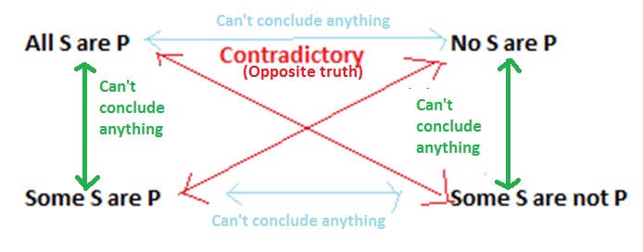

On the Boolean interpretation, the truth value of “All S are P” is the opposite of “Some S are not P.” (If one is true, the other is false.). Similarly, the truth value of “No S are P” is the opposite of “Some S are P.” This is called the **contradictory** relation. Using the modern square of opposition, we can tell that the following immediate inferences (which use the contradictory relation) are valid:

* All doctors are clowns. So, it is false that some doctors are not clowns. (VALID)
* It is false no vegetarians are overweight people. So, some vegetarians are overweight people. (VALID)

**Existential Fallacy.** On the Boolean interpretation, universal statements (“All” or “No”) do NOT entail the existence of the terms. However, the particular statements (“Some”) DO entail existence. Because of this, the Boolean interpretation holds that the following arguments are invalid, since they commit the **existential fallacy** (they try to go from a universal premise to a particular conclusion):

* All detectives are jerks. So, some detectives are jerks. (INVALID)
* No scissors are dull things. So, some scissors are not dull things. (INVALID)

## The Traditional Square of Opposition

Similarly, the Aristotelian interpretation can be represented by the **traditional square of opposition**.It always assumes that at least one S exists, even for universal statements. Because of this assumption, there are a number of new, important relationships between statements.

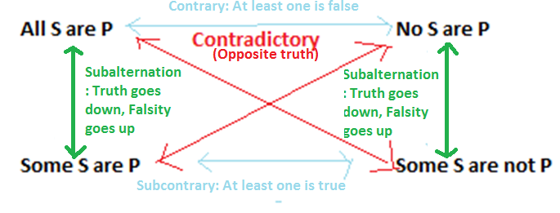

The Aristotelian (traditional) interpretation can be represented by the traditional square of opposition.It always assumes that at least one S exists. The **contradictory relationship** is the same as before. **Obversion, conversion,** and **contraposition** all work. However, there are few new rules as well.

**Subalternation** refers to a relationship between universal and particular statements with the same quality. It is unique to the Aristotelian tradition. (“Truth flows downward, falsity flows upward.”)

* If “All S are P” is TRUE, then “Some S are P” is TRUE. If “No S are P” is TRUE, then “Some S are not P” is TRUE.
* Ex: If “all mustangs are horses” is true, then so is “some horses are mustangs.”
* If “Some S are P” is FALSE, then “All S are P” is FALSE. If “Some S are not P is FALSE”, then “No S are P” is FALSE.
* Ex: If “some dogs are cats” is false, then “all dogs are cats is false.”

The **contrary** relationship holds between universal statements. It says that it is impossible for BOTH “All S are P” and “No S are P” to be true. However, they might both be false.

* Ex: Since “all cats are mammals” is TRUE, we can conclude “no cats are mammals” is FALSE.

The **subcontrary** relationship (“At least one universal statement is FALSE. At least one particular statement is TRUE.”) holds between particular statements. It says that it is impossible for BOTH “Some S are P” and “Some S are not P” to be FALSE.

* Ex: Some “Some cats are not mammals” is FALSE, we can conclude that “Some cats are mammals is TRUE.

## What is a Venn Diagram?

A **Venn diagram** is a way of visually representing the content of a categorical statement. SHADING means “nothing is here”. An “X” means “something is here.” No area that is SHADED can have an X.

|  |  |  |
| --- | --- | --- |
|  | Boolean/Modern Diagram | Traditional/Aristotelian |
| **All S are P (A)** | To represent an A-statement on the Boolean interpretation, we SHADE the area where things that are S but not P would go. According to the contradictory relationship, this is equivalent to the claim that “Some S are not P” is FALSE. | On the Aristotelian tradition diagram for A-statements, we have the exact same shading as on the Boolean. However, we add a circled ‘X’ to indicate that we are *assuming* that at least one thing actually is S. This entails that “Some S are P” is TRUE, “Some S are not P” is FALSE, and “No S are P” is FALSE. |
| **No S are P (E)** | To represent an E-statement on the Boolean interpretation, we SHADE the area where things that are both S and P would go. According to the contradictory relationship, this is equivalent to the claim that “Some S are P” is FALSE. | On the Aristotelian diagram for E-statements, we have the exact same shading as on the Boolean. However, we add a circled ‘X’ to indicate that we are *assuming* that at least one thing actually is S. This entails “Some S are not P” is TRUE, “Some S are P” is FALSE, and “All S are P” is FALSE. |
| **Some S are P** |  | For particular statements, there is no difference between Aristotelian and Boolean statements.  We represent I-statements (on both Boolean and Aristotelian interpretations) by putting an X in the appropriate place. This also entails that “No S are P” is FALSE. |
| **Some S are not P** |  | For particular statements, there is no difference between Aristotelian and Boolean statements.  We represent O-statements (on both interpretations) by putting an X in the area of S that is NOT part of P. This statement is equivalent to the claim that “All S are P” is FALSE. |

## Using Venn Diagrams to Test Immediate Inferences (Boolean)

Testing the validity of an argument using Venn diagrams is very easy:

1. You draw a Venn diagram that representing the premises.
2. You put you pencil down, and then look to see if it is *possible* for the conclusion to be false. If it helps, you can draw a second Venn diagram representing the conclusion (and see whether it matches the premise).
3. If it is possible for the conclusion to be false, then the argument is invalid. If it is NOT possible for the conclusion to be false (the conclusion is *guaranteed* to be true), then the argument is valid.

**Hint: Drawing diagrams for a “false” statement.** Sometimes, you’ll want to draw a diagram for a premise or conclusion that is FALSE. (Example: “It is false that all S are P”.) To do this, you (1) begin by drawing the statement while ignoring the “it is false that” (so, you draw a diagram for “All S are P”). Now, you (2) replace the shading with Xs, and the Xs with shading. Leave everything alone. So, it looks like this:

|  |  |
| --- | --- |
| Statement: “All S are P” | Statement: “It is false that all S are P”  (This is the same as “Some S are not P”!) |
|  |  |

## Solved Problems

Use the modern square of opposition and your knowledge of Venn diagrams to determine whether the following arguments are valid or invalid.

|  |  |  |  |
| --- | --- | --- | --- |
| **Passage** | **Diagram: Premise** | **Diagram: Conclusion** | **Valid?** |
| All vampires are undead creatures. So, all undead creatures are vampires. |  |  | No! The conclusion claims the far right area is shaded. The premise does NOT say this. |
| Some zombies are brain-eaters. So, some brain-eaters are zombies. |  |  | Yes! The diagrams match exactly. |
| No ghouls are ghosts. So, some ghouls are not ghosts. |  |  | This WOULD be valid on the Aristotelian interpretation . However, it is NOT valid on the Boolean interpretation. |
| Some witches are wizards. So, it is false that no witches are wizards. |  |  | Valid! Note that this involves diagramming a false statement. |
| No werewolves are basset hounds. So, it is false that all basset hounds are werewolves. |  |  | Invalid! (Note that this would be valid on Aristotelian, since we would assume that Bassett hounds actually exist). |

## Review Questions

Using the Boolean standpoint, determine whether the following arguments are valid or invalid by drawing Venn diagrams.

1. No Ewoks are wookies. So, no wookies are Ewoks.
2. Some adults are fans of cartoons. So, some fans of cartoons are adults.
3. Some types of cancer are not treatable diseases. So, some treatable diseases are not types of cancer.
4. All Charles Dickens novels are fun books to read. So, some Charles Dickens novels are fun books to read.
5. No things that Iago says are things that you ought to believe. So, all things Iago says are things you ought not believe. (Here “things you ought not believe” is the **complement** of “things you ought to believe.” They take up opposite areas of the Venn diagram.)
6. All existing things are material objects. So, no material objects are non-existing things. (Again, this involves a term and its complement).